The Niamh Louise Foundation
Breaking the Silence in Rural Areas Research Project
Report

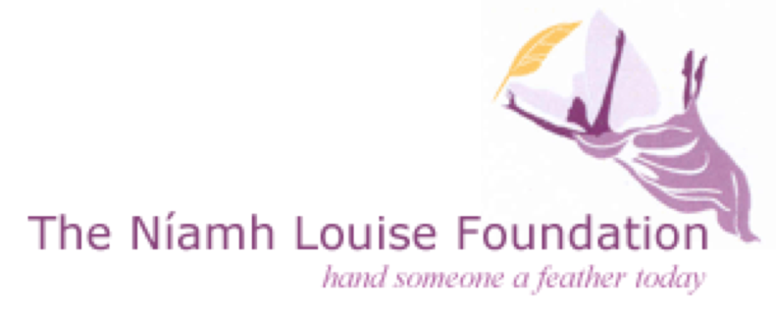

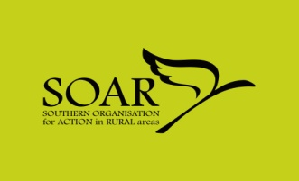

Holywell Consultancy Ltd.

12-14 The Diamond, Derry/Londonderry, BT48 6HW, (028) 7126 7997, info@holywellconsultancy.com, www.holywellconsultancy.com

Contents

Section | Page
1. Introduction | 3
2. Methodology | 5
3. Main Findings | 7
4. Appendices | 33

Section 1 – Introduction

Background – The Niamh Louise Foundation (NLF)

  - The Niamh Louise Foundation was founded in February 2006 following the death of 15 year old Niamh Louise McKee who died by suicide. The mission of the organisation is to provide a safe environment where anyone can drop in to chat about worrying thoughts, thoughts of suicide and/or self harm.

1.2 The NLF received funding from the Southern Organisation for Action in Rural Areas (SOAR) to conduct a research project within rural communities in Craigavon, Armagh and Newry to build increased awareness and understanding around the needs of rural residents requiring help and support on mental health, self-harm and suicide related issues. Holywell Consultancy were commissioned to deliver the research project.

1.3 The aim of the research is to develop a substantial knowledge base that will allow the NLF and other agencies to better meet the presenting needs and issues within rural communities. The information will be used to inform policy and practice of stakeholders who have a role in addressing issues related to suicide, self-harm and emotional well-being.

Research Objectives

1.4 The research objectives of the Breaking the Silence in Rural Areas Research Project are as follows:

- Examine & baseline current status and availability of help available in rural areas as regards mental health, suicide and self-harm within the rural areas of Craigavon, Armagh and Newry from across the statutory, community and voluntary sectors.
- Explore current perceptions, attitudes and experiences by communities, families and individuals in relation to service provision and stigma, as well as identifying gaps and shortfalls.
- Seek to explore how real an issue stigma is and how best this might be overcome within the rural context, especially for those communities, groups and individuals presenting the greatest level of ‘risk factors’.
- Consider international good practice in terms of suicide, self-harm emotional well-being service and support delivery with rural contexts and especially models that demonstrate efficacy in addressing the issue of stigma.
- Advise and make recommendations on the basis of the research in its totality how the Niamh Louise Foundation and others can deliver improved community services within the catchment areas of Craigavon, Armagh and Newry and set out a series of recommendations for how services across sectors might be improved in order to provide greater seamless and integrated service which is centred on the genuine needs of those experiencing issues related to suicide, self-harm and emotional well-being.

Section 2 – Methodology

Introduction
2.1 The Breaking the Silence in Rural Areas research was conducted in the areas of Craigavon, Armagh and Newry. Holywell Consultancy adopted a very sensitive approach to conducting the research given the nature of the subject.

Holywell Consultancy have taken direction from The Niamh Louise Foundation and have written this report in a manner to ensure it is as clear and accessible to as many people as possible.

Research Methods
2.2 Holywell Consultancy adopted a number of different approaches to gather information for the research project:

Desk Based Research
Holywell Consultancy gathered and analysed a wide range of documents (a full list is available in Appendix 1) in order to inform the Breaking the Silence Research Project.

Survey Questionnaire
An online questionnaire was designed in collaboration with the Niamh Louise Foundation. The questionnaire was targeted towards those who have and are receiving support, those who have been bereaved by suicide and those who work in the support field either within a community setting or as part of a statutory service provider.

Respondents were assured of their anonymity given the sensitive nature of the subject. A link to the online questionnaire was disseminated to health representatives, support workers and those who have accessed support services via the NLF contacts database. Holywell Consultancy also issued reminders to potential respondents.

The questionnaire included many open-ended questions and space for respondents to elaborate on their responses. This provided the opportunity for respondents to give full and unprompted responses. A copy of the survey questionnaire is available in Appendix 5.

Engagement
Focus Groups
Holywell Consultancy conducted 2 Focus Groups. The Focus Groups took place in Ballymacnab and Portadown. Despite two attempts we were unable to organise a focus group in the Laurelvale/Newry area.

For details of the participants involved in the Focus Groups see Appendix 3. Again participants were assured that all information gathered would be treated in confidence and that their comments would not be attributed to them within the research report. Holywell Consultancy adopted a very sensitive approach given the subject area and participants were encouraged only to share the information that they felt comfortable with sharing.

Interviews
Holywell Consultancy conducted 29 semi-structured interviews. These included telephone and face to face interviews. Holywell Consultancy ensured that a wide range of interviewees were involved in the research project. Interviewees included: individuals and families who had been bereaved by suicide; individuals who have accessed mental health support; support workers; and representatives from health agencies/health trusts. Again information gathered was treated sensitively.
Section 3 – Main Findings

Introduction
The body of this section of the report follows the layout of the research objectives listed in Section 1 and therefore contains the following sub-sections:

1. Baseline of current help available within the rural areas of Craigavon, Armagh and Newry
2. Service provision and gaps/shortfalls
3. Stigma and how to overcome the stigma
4. International Good Practice
5. Recommendations.

Definitions of some of the terms used in this report are included in Appendix 2.

Baseline of current help/provision
3.1 In order to inform the Breaking of the Silence Research Holywell Consultancy conducted extensive desk research into the current and relevant literature with regard to mental health provision in Northern Ireland. This includes policy documents and relevant research in order to provide background information and to set the context of current mental health provision in Northern Ireland.

Desk Research
Suicide is the act of deliberately ending one’s own life and is among the top 20 leading causes of death globally for all ages. According to recent research conducted by the University of Ulster, Public Health Agency and Queens University Belfast, almost one million people die by suicide every year, a ‘global’ mortality rate of 16 per 100,000 or one death every 40 seconds. 1 In 2010 313 deaths in Northern Ireland were registered as suicides compared to 213 in 2005. Between 1999 and 2008 there was a 64% increase in suicide in Northern Ireland.

The following chart indicates the increase in suicide rate in Northern Ireland from 1997 to 2010. The chart also illustrates the number of deaths by suicide compared to the number of deaths due to Road Traffic Collisions:

This alarming rise in suicide particularly among young men prompted the DHSSPS to produce the Northern Ireland Suicide Prevention Strategy, ‘Protect Life: A Shared Vision 2006-2011 and is the main framework policy document in the field of mental health and suicide prevention.

Below follows a summary of the main policy documents within the field of mental health, suicide and self-harm.

3.1.1 Policy Documents
The Protect Life Strategy – a Taskforce was set up to develop a Suicide Prevention Strategy for Northern Ireland. In addition to extensive engagement the following work was also carried out to inform the Strategy: an analysis of the levels of suicide; a review of the evidence base and identification of best practice in Northern Ireland and other areas; and a review of the implementation of the ten suicide prevention action points in the Promoting Mental Health Strategy and Action Plan.

The objectives of the Strategy & Action Plan are to:
- Raise awareness of mental health and well-being issues;
- Ensure early recognition of mental ill-health, and provide appropriate follow-up action by support services;
- Develop co-ordinated, effective, accessible, and timely response mechanisms for those seeking help;
- Provide appropriate training for people dealing with suicide and mental health issues;
- Enhance the support role currently carried out by the voluntary/community sectors, bereaved families, and individuals who have made previous suicide attempts;
- Support the media in the development and implementation of guidelines for a suitable response to suicide-related matters;
- Provide support for research and evaluation of relevant suicide and self-harm issues; and
- Restrict access, where possible, to the means of carrying out suicide.

A cross-sectoral Suicide Strategy Implementation Body has been established to oversee and drive forward the Strategy & Action Plan. The implementation of the Strategy & Action Plan is reviewed on an annual basis, with responsibility resting on the Suicide Implementation Body and the DHSSPS.

The Bamford Review of Mental Health & Learning Disability - was commissioned to review the effectiveness of current policies and service provisions relating to mental health and learning disability and of the Mental Health Northern Ireland Order 1986. The Review began in 2002 and was completed in 2007 and compiles a number of inter-linked reviews.

The Review comprises policies, services, and legislation and addresses how best to provide services to people with specific mental health needs or a learning disability in accordance with and to promote the social inclusion of the statutory equality obligations of the Northern Ireland Act 1998 and with the Human Rights Act 1998.

The Bamford Review recommended an investigation of factors impacting on suicidal behaviour and the impact of interventions and services on individuals, their families and carers.

Promoting Mental Health Strategy & Action Plan, 2003-2008 (Investing for Health)
In the Programme for Government, the Northern Ireland Executive committed itself to “working for a healthier people”, promising to promote mental and emotional health to reduce suicides. This strategy outlines 30 actions towards an integrated approach to address the wider determinants of mental health as a priority. It addresses mental health promotion at three levels: strengthening individuals, strengthening communities, and reducing structural barriers to mental health.

The Strategy hopes to:
- improve mental and emotional well-being, especially for those who are at risk or vulnerable, and those with mental health problems, as well as their carers and families;
- prevent or improve the occurrence and impact of mental and emotional distress, anxiety, mental illness, and suicide;
- raise awareness of the determinations of mental and emotional health at public, professional, and policy-making levels to reduce discrimination and stigma against those with mental health problems;
- ensure that all involved individuals are knowledgeable, skilled, and aware of the effective practice in mental and emotional health promotion.

The actions of the Strategy are grouped in four areas: policy development, raising awareness and reducing discrimination, improving knowledge and skills, and preventing suicide.

The annexes of this document include useful information about mental and emotional health, effective mental and emotional health promotion, suicide prevention, and equality implications.

Northern Ireland Health and Social Care Services Strategy for Bereavement Care - A region-wide multi-agency group from Health and Social Care, in partnership with groups in the community and voluntary sector, has generated a strategy for bereavement care. This is in response to the 15,000 people across Northern Ireland who die each year, many in hospitals, hospices, or nursing homes (73% total). Many who work in Health and Social Care come into contact with those who are dying and those affected by bereavement - this strategy aims to build the capacity of all those who have such contact to respond appropriately and sensitively to the needs of those affected.

The six key standards identified were:
- Raising awareness;
- Promoting safe and effective care;
- Communication, information, and resources;
- Creating a supportive experience;
- Knowledge and skills; and
- Working together.

3.1.2 Other Relevant Research

The following includes a summary of key research/literature particularly relevant to the Breaking the Silence research project:

The National Confidential Inquiry into Suicide and Homicide by People with Mental Illness - This inquiry began at the University of Manchester in 1996 and extended to Northern Ireland in 1997 and is intended to increase the understanding of the risks of suicide in people with mental illness and how to respond more effectively to those risks to reduce suicide by those who use mental health services in Northern Ireland.

From 2000-2008, there were 533 suicides in current mental health patients – 29% of all suicides. More young people die by suicide in Northern Ireland than in other UK countries – 332 in people under the age of 25 from 2000-2008. These young people were most likely to be living in poorer areas and have the lowest rate of contact with mental health services. Alcohol misuse was a common feature in patient suicide (60%) and dual diagnosis (severe mental illness and alcohol/drug misuse) was found in 1 in 4 patient suicides. Thirty-five in-patient suicides occurred during 2000-2008 - 7% of all patient suicides; eight were related to problems of observation because of ward design, 28 occurred off the ward, and eight while the patient was under observation. Post-discharge care is also a concern, as 24% of suicides occurred within three months from discharge from the hospital. Additionally, 27% of patients missed their final appointment with services.

In general, the rate of suicide in Northern Ireland increased from 1998 to 2008. Males outnumbered females three to one, and most suicides that occurred were young and middle aged men.

The report made recommendations around close monitoring of the suicide rate in the general population and in the main demographic sub-groups as evidence of the effectiveness of the Protect Life strategy. Other recommendations include reducing alcohol misuse and dependence as a step towards reducing the risk of suicide, and services should introduce an assertive outreach function into community mental health services and initiatives to combat the stigma of mental illness should emphasise the low risk to the general public from mentally ill patients living in the community.

The Trouble with Suicide: Mental Health, Suicide and the Northern Ireland Conflict: A Review of the Evidence – This review was conducted to assess the evidence of the effects of the Northern Ireland conflict on mental health and well-being, especially in reference to suicide and is part of the Suicide Prevention Strategy. In Northern Ireland, there is concern for those who are “driven” to suicide through physical or mental bullying, violence, and intimidation of others. This sometimes manifests as punishment beatings in paramilitary groups, which some believe have led to the growth of suicide among young men in North Belfast. The difficult conditions associated with violent conflict alter the way suicide intention is understood, such as in the hunger strikes. Suicides have been on the rise among younger people and the public is pressuring for an appropriate response to raise awareness of and prevent suicides.

This work concluded that the evidence that experience of the conflict is associated with poorer mental health is strong. Those who experience most violence have significantly higher rates of depression than those with significantly no experience of violence. And those whose areas were heavily effected by violence had very high rates of depression.

Of particular relevance to the Breaking the Silence research was the question raised in this piece of work of whether there is a distinctive rural suicide problem associated with rural isolation and/or the particular problems facing farmers and rural communities.

AMH Menssana – Young Peoples Mental Health - This research identified the need for information and support in relation to young people’s mental health in the Southern Health & Social Services Board and Southern Education & Library Board areas. The research focused on establishing parents’ and professionals’ awareness, experience and perceptions of existing service provision for young people’s mental health and identify gaps where new services are needed. To identify specific issues relating to young people’s mental health where further information and support are required and establish key contacts’ needs and preferences regarding the nature of this support.

The conclusions and recommendations from this investigation contributed to improving future mental health service provision and AMH Menssana to use the findings to shape the development of an accessible and appropriate information and support service within the community that is tailored to meet the needs of the key contacts of young people.

Some of the recommendations included the need to create opportunities to promote awareness and understanding around mental health issues to reduce stigma and misconceptions and mental health promotion to begin at an early age.

Providing meaningful care: using the experiences of young suicidal men to inform mental health care services – The aim of this study was to obtain an understanding of suicidal behaviour amongst men aged 16-34 to underpin the provision of accessible, acceptable and appropriate mental health services. The research questions of this particular study were: How can mental health services be best configured to encourage their use by suicidal men aged 16-34? And what is the required response of mental health care services
for suicidal men, aged 16-34? Recommendations included the need for community-based services, ongoing and long-term support for young men to move on once the initial risk of suicide has been removed and services need to continue to address issues around stigma.

3.1.3 Baseline of current help/provision – Craigavon, Armagh & Newry

With regard to the provision in the Craigavon, Armagh and Newry areas the following summarises the key organisations and the support that they provide. The Southern Trust area Lifeline has contracts with a range of community/voluntary sector organisations to provide wraparound services including counselling, mentoring and befriending. The following organisations have arrangements in place with Lifeline to provide these services:

Counselling

Organisation | Area
REACT Ltd | Newry/Banbridge/Armagh areas
CARECALL | Provides regional cover
Breakthru | Dungannon/Portadown/Lurgan/Armagh
Mid Ulster South Tyrone Association (MUST) | Dungannon
LifeSpring | Newry

Mentoring

Organisation | Area
REACT Ltd | Newry/Armagh/Banbridge
Niamh Louise Foundation | Dungannon/Armagh/Coalisland
Opal Training | Armagh/Ballymacnab

Complimentary Therapies

Organisation | Area
Feel Great Therapies | Armagh
Niamh Louise Foundation | Dungannon/Armagh/Coalisland
Lifespring | Newry
Mid Ulster South Tyrone Association (MUST) | Dungannon area
Protect Life Community of Interest Company | Banbridge/Craigavon/Lurgan/Portadown

In addition to the above organisations who have contracts with Lifeline the following organisations also provide support in the field of mental health, suicide and self-harm:

Organisation | Area
PIPS | Newry & Mourne
Samaritans | Throughout Northern Ireland
Lifeline | Throughout Northern Ireland
CRUSE Bereavement Care | Newry & Mourne

Statutory agencies who provide help in the field of mental health, suicide and self-harm in Craigavon, Armagh and Newry includes the:

- GP
- Out of Hours/Crisis Response Team
- Home Crisis Response Team
- Mental Health Team
- Child & Family Team
- PSNI

3.2 Service Provision

Holywell Consultancy analysed the results from the survey questionnaire (for detailed results of the survey questionnaire see Appendix 5) together with the information gathered during the focus groups and interviews. The following outlines the findings from our analysis:

Interviews

Holywell Consultancy conducted 30 interviews. A list of interviewees is detailed in Appendix 3. A full list of the interview trigger questions is included in Appendix 4.

Focus Groups

Holywell Consultancy organised 2 focus groups, one in the Ballymacnab area and one in the Portadown area. A list of attendees at each of the focus groups is detailed in Appendix 3.

The interviews and focus groups focused on:

- Accessibility of services
- Adequacy of support
- Rural areas – suicide risk

The points raised during discussions are summarised under the themes listed above.

3.2.1 Accessibility of services
Those respondents who had accessed services were asked if they felt it was easy to access support. The points raised have been summarised under positive comments and challenges:

Positive Comments

- Some interviewees felt that support was easy to access particularly support provided by community organisations such as The Niamh Louise Foundation. Many had heard through a friend of the Niamh Louise Foundation and on contacting the Foundation they were able to access help immediately. They also felt reassured that the support they received was indefinite.

- Others felt that the support was easy to access once their GP had referred them to mental health support and that the service was timely and appropriate.

Challenges

- Some felt that it was difficult to access support due to the lack of transport available in rural areas which made it harder to attend appointments.

- Others felt that waiting lists within the Health Service (13 weeks sometimes for a referral) were too long for someone who is need of mental health support and that this may exacerbate their symptoms/situation.

- Some raised the issue with regard to access during out of hours and weekends. It was pointed out that it is difficult to access help if people reach a crisis point during these times and it is difficult for families to cope if they cannot access professional advice and assistance.

- Another strong theme running through responses was that people felt that there was a lack of awareness of the help that was available to people who need support with a problem around mental health, self-harm or suicide. Consequently some people who need help are totally unaware of who to contact.

Evidence of the above findings is also reflected in the results from the survey.
15 out of 29 survey respondents indicated that they felt there was a low level of accessibility for services and support for people experiencing mild mental health problems, with 7 out of 29 indicating that they felt that services were moderately accessible for those suffering from mild mental health problems. 12 out of 29 respondents indicated that they felt there was a low level of accessibility for services and support for people experiencing severe mental health problems and 10 felt services were moderately accessible.
The chart below illustrates the overall survey responses to accessibility of services.

3.2.2 Adequacy of support
Interviewees and focus group participants were asked if they felt there is adequate support available for rural communities with regard to mental health, self-harm and suicide. The key issues arising were as follows:

Positive Comments

- Some interviewees felt that the level of support they received from, for example, their Key Worker was very good and that the Mental Health Home Team were very supportive.

- A few interviewees felt that their GP was supportive.

- Many felt that the community and voluntary sector are invaluable in reaching people in need. For example many felt that The Niamh Louise Foundation is a great source of support. For instance, it was felt that the support through The Niamh Louise Foundation was easy to access and the network through friendships/relationships that has developed between those who access support there, was a source of great help.

Challenges

- Some of those engaged with felt that there was a lack of continuity with support workers within statutory agencies. Some found that they had to engage with a different worker each time they attended an appointment. This was traumatic having to re-tell their story each time and they felt as if the Support Worker had not read their notes/file as they did not know their history or what medication they were on.

- With regard to GPs some interviewees felt that their GP was very quick to prescribe medication rather than take the time to talk to the patient to find out if there was an alternative to medication. Some interviewees reported that their GP had a poor attitude to their mental health problem and they felt the GP was quite dismissive.

- Home Treatment Crisis Response Team – some felt that this service was still evolving and under-resourced. Their aim to abate a crisis and avoid hospitalisation, may be in the best interests of the individual but often people live with families that may need the respite for their own self-care. Families are often left to deal with issues alone. Avoiding hospitalisation, whilst honourable can be to the detriment of other people’s mental health.

- It was pointed out that the statutory system is slow. People have found themselves on waiting lists (sometimes up to 13 weeks).

- Other respondents felt that service providers are keen to withdraw quickly and seldom are long-term plans put into place in order to ensure the client is receiving long-term care.

The results from the online survey also reflected mixed reactions to the effectiveness of services. This is reflected in the chart below.

3.2.3 Rural areas – suicide risk
Interviewees and focus group participants were asked if they felt members of rural communities were more at risk of suicide. The key issues arising were as follows:

Positive Comments
- It was pointed out that the ‘closeness’ of communities was a positive element of living in rural areas. Neighbours look out for each other and provide support to each other during difficult times.

Challenges

- Some interviewees felt that people in rural communities are more isolated. Neighbours are not as close by and there can be issues with regard to having access to transport in order to reach help.

- It was also highlighted that if someone needs mental health support this may go unnoticed in the rural community. There is more opportunity to get ‘lost’ rurally.

- It was pointed out that there is an element of ‘closeness’ within rural communities in that everyone knows everyone’s business. People may not want their neighbours to know they are suffering from mental ill-health and that this may deter people from getting help.

- Some of those we engaged with intimated a cultural difference between people living in rural areas and people living in urban areas. It was felt that there is maybe a more ‘invincible’ attitude amongst rural residents in that they feel they have to be ‘broad-shouldered’ and ‘soldier on’ rather than admitting that they need some help.

- Farmers – many interviewees highlighted distinctive problems facing farmers in rural communities. These include isolation and the need to ‘keep the farm going at all costs’. Accessing services may be difficult for the farming community, particularly men, as they can often feel they have to be the ‘man of the house’ and accessing help may be perceived as a weakness. Some interviewees also raised the issue around farmers having access to very definite means of suicide.

- Many interviewees felt that suicide is not simply an urban or rural issue but that if affects people no matter where they are from or where they live.

3.2.4 Summary of Gaps/Shortfalls
The following is a summary of the gaps and shortfalls that have been highlighted by respondents to the survey questionnaire and through the engagement process.

Service provision
- Lack of provision of services outside of normal working hours, for example clinics, which can lead to an increased sense of isolation within rural communities.

- There is a lack of support for young people who need care – there are only 12 beds in Northern Ireland for young people between the ages 15 &18 years who need mental health support and there are huge waiting lists for this type of support.

- There is a gap between the community and voluntary sector and GP’s. GP’s need to be more aware that the organisations within the community sector are skilled, well-trained and are providing excellent support from which many people are benefiting.

- Continuity of care – for many of those we engaged with the lack of continuity with regard to their care was an issue. Those who had accessed support had to engage with a different key worker each time so they had to re-tell their stories/problems each time. This left them feeling traumatised at having to re-live bad times. There were also times when key workers had not read their notes and did not know what medication they were on and again they felt like they were ‘on a conveyor belt’ with no one really showing genuine concern for them.

- Some of those we engaged with felt that there was not enough local and primary care, particularly not enough access to counselling services. Some people have to wait 13 weeks for a referral and then often GPs prescribe medication in the mean time. This may not be the best solution for everyone.

- There is a lack of connection with drug and alcohol support and mental health services. Drugs and alcohol impact on mental health and should be joined up with mental health under the Protect Life banner.

- There is a lack of support for carers of relatives who are suffering from poor mental health. CAUSE are the only official organisation throughout Northern Ireland that support carers. Other organisations find themselves offering support to carers who come to them for support. In addition there is there is a lack of funding to provide respite for carers.

- Victims of the Troubles – for some victims of the Troubles, the impact of the Conflict/Troubles has not been dealt with yet. The intergenerational aspect of the Conflict is also an issue and the impact that the Troubles continue to have on young people.

- There is a lack of externally verified standards with regard to services provided by the community support groups. The CLEAR project which operates in Derry, Strabane, Omagh, Limavady and Fermanagh is a partnership initiative offering developmental opportunities to community and voluntary organisations providing mental health and emotional well-being services in the western area has implementing quality standards for best practice in service delivery. It is planned that the CLEAR standards will be rolled out throughout Northern Ireland.

- In the Warrenpoint area of Newry it was very clear that there are a number of people who are not receiving the help that they require. The Niamh Louise Foundation have helped but are limited as to how much they can do as they do not have a base in the area.

Medication
- At times the route problem of an individual’s mental health can be directly linked to the provision of medication but paradoxically the problem cannot be addressed with the individual due to the effects of the medication. The medication may leave them feeling ‘woolly headed’.

- Medication reviews need to be regular. Some people can be on the same medication for years and their needs may have changed. This can have a detrimental affect both physically and mentally.

Stigma – as a barrier to accessing support
- The stigma associated with mental health can deter people from getting the help and support that they need. They do not want to be labelled as someone who is ‘mentally ill’ and do not want to be judged/perceived as different.

- There is a challenge around encouraging key groups, particularly young men and men from the farming community, to seek help when they need it. This challenge also includes trying to dispel the myths around accessing help which may be perceived as a weakness.

- Clergy are often the first point of call for those suffering from poor mental health but are often not skilled in identifying issues or not informed to sign-post people to support and services.

3.3 Stigma

- All of the interviewees felt that there is a general stigma in relation to mental health illness. This stigma prevents people from accessing services and support.

- Some felt the stigma may be greater in rural areas as there is an element of closeness within rural communities so people who may have mental health problems feel people will be talking about them if they access services.

- Many felt that there is a need to normalise mental health issues so that people are more understanding and accepting and realise that there is no shame in needing help.

- It was also pointed out by many that mental illness is not unique to one person and anything can trigger it such as normal life experiences such as the loss of a loved one, losing your job and relationship problems. This message needs to be promoted better.

The results from the online survey with regard to mental health related stigma indicated that some feel there has been no change with regard to stigma over the last three years and others feel that it has got better. These results are illustrated below:

3.3.1 Addressing Stigma

Interviewees and focus group participants were asked how they felt that the stigma around mental ill-health could be addressed:

- Many felt that it was necessary to increase the understanding around mental health so that people can regard mental health on a similar vein as physical health. Encouraging people to realise that it does not mean that you are weak if you need help with a mental health issue.

- Interviewees felt that more education and positive promotion around mental health was essential. Presenting mental health positively by providing examples of well-known figures who have succeeded and coped with mental illness at the same time.

- A strong theme emerging was around mental health promotion and mental health awareness beginning as early in life as possible, starting this in nursery and primary school right through to adult life.

- Many felt that promoting mental health in youth clubs, sports clubs, and the workplace in order to try and normalise mental health issues was very important. There is a need to training leaders of such organisations in ASIST and Mental Health First Aid, so that they are more aware of and can read the signs of mental ill-health and potential suicide.

- Politicians, community leaders and senior influencers need to raise mental health issues so that people will know how and where they can get support.

3.4 International Good Practice

Holywell Consultancy conducted extensive desk research in order to source: (1) relevant documents and information on international good practice with regard to mental health, self-harm and suicide in rural areas;
(2) and international good practice examples in addressing stigma around mental health and suicide.

The following section includes information on Australia, America, South Africa, New Zealand, England and Scotland and examples of their approach to suicide prevention and to addressing the stigma surrounding mental health and suicide.

3.4.1 Australia
Suicide rates in rural and remote areas of Australia are significantly higher than the national average. According to the Australian Institute of Health and Welfare the suicide rates are 33% higher in rural areas than in major cities rising to 189% higher in very remote areas.

Some of the factors affecting mental health and contributing factors to the higher suicide rate in rural areas includes:

(1) financial difficulties/economic hardship
(2) isolation – less face to face contact leading to loneliness and depression
(3) tendency to postpone seeking medical services for illness or psychological problems until it is economically/socially convenient
(4) reluctance to expose their private lives to strangers/acquaintances from locally based services or to journey somewhere distant where cultural/behavioural differences could be misunderstood
(5) social stigma – lack of privacy/confidentiality, everyone knows everyone’s business in rural areas
(6) attitudes in rural areas – ‘broad-shouldered’ behaviours, strong work ethic
(7) characteristics of rural people – less help-seeking – tendency to persevere, be resilient and resourceful
(8) lack of access to support services – limited access to community support services and mental health services and limited access to internet or telephone.

Examples of good practice – Australia

Coach the Coach – training local sports coaches to become more aware of depression and symptoms of depression and to promote mental health and well-being among rural men.

Mens Shed Programme - addresses the issues of men’s health (physical, emotional, social and spiritual well-being) in the community and engages men of all ages, differently-abled, youth, veterans and other groups of men of the communities in regional, rural, remote and urban areas. The programme supports the social interaction of men in transitional periods (e.g. Redundancy, Bereavement, Retirement, ill-Health, Relocation, Divorce, Respite Care) in a non-exclusive, non-judgemental way and helps to share, disseminate and preserve the skills, abilities and interests that are relevant to the community.

Mental Health First Aid programme – designed to train individuals to assist others who are developing a mental health problem or who are in mental health distress.

Working with Warriors – a free DVD on rural men’s mental health. The first resource of its kind in Australia, the DVD unravels the pressures placed on farming men, the symptoms of depression and the key first steps towards managing the problem – for farmers, their families and the extended rural community. This initiative was awarded the 2008 Life Award for Business and Industry.

The Rural Alive and Well Tasmania programme - designed to provide support to rural men and their families in ‘exceptional circumstances’ in drought areas of the Southern Midlands and Central Highlands, where emotional and physical trauma brought on by the pressures of drought and economic hardship are prevalent. Mental health ‘first aid’, complemented by suicide prevention training, reach as many members of remote, rural and regional communities as possible; bearing in mind that it is, quite often, family members, work colleagues, teachers, and/or sports coaches who are the first responders to an individual at-risk or in crisis.

Mind Matters - MindMatters is a national mental health initiative for secondary schools funded by the Australian Government Department of Health and Ageing. It is about creating support for the mental health and wellbeing of all students, including those experiencing high support needs. It also involves increasing staff understanding of mental health and wellbeing. The project helps school communities create a climate of positive mental health and wellbeing and to enable schools to better to collaborate with families and the health sector.

3.4.2 America

Suicide is the fourth leading cause of death for adults between the ages of 18 and 65 years in the United States (29,668 suicides). A person dies by suicide about every 15 minutes in the United States. Western and mountain states consistently have higher suicide rates than the rest of the country and all of the states with the highest suicide rates have many counties that would meet most definitions of ‘rural’.

Some of the factors affecting mental health and contributing factors to the higher suicide rate in rural areas includes:

- Lack of resources and access to care
- Remoteness leads to homogeneity, isolation and insularity, which can sometimes lead to lack of privacy.
- Economic decline – unemployment and poverty
- Due to tight-knit communities a suicide death can impact everyone because communities may not have experienced a suicide death before, lack of experience and tendency to suppress knowledge about suicidal behaviour can lull community members into believing that ‘we don’t have these problems’.

Examples of good practice - America
Mental Health America of Wisconsin is a practical example of an organisation who have implemented a suicide prevention toolkit, particularly targeted towards young people. Their toolkit consists of 9 elements, of particular interest is their Gate Keeping Training. The term "gatekeeper" refers to any individual within the community who is in a position to observe "high-risk" behaviors and take action. The goal of these trainings is to equip its participants with basic suicide prevention education and intervention skills. Another key element is their regular evaluation tools utilised throughout delivery to measure the impact of the programme.

3.4.3 South Africa
Approximately six to eight thousand people die by suicide in South Africa every year, making suicide the third greatest cause of unnatural death in the country after homicide and unintentional causes. On average 9% of deaths in young people, especially black youth, in South Africa are due to suicide.

Examples of good practice – South Africa
SADAG – South African Depression & Anxiety Group (SADAG) - Teen Suicide Prevention Campaign – Draw with Me Project - The concept of this project is a conversation between two anonymous students through writings and drawing on a school desk. These were then brought to life through an animation to show the story of their interaction and how even a simple conversation can offer hope to the hopeless. Therapists and SADAG members were interviewed to gain insight into the behaviour of suicidal teens and workers also spoke to some young adults who had previously experienced suicidal behaviour and depression while in school. All of this information formed the basis of an advertisement. The aim of the ad was to take the taboo out of mental health issues and suicide. The group won an award for their advertisement.

Making Rural Mental Health Accessible – This project was targeted towards remote rural areas in South Africa with little or no resources and no hope. Trained counsellors educated community leaders and professionals about the warning signs of mental illness and suicide so that they can more effectively assist people suffering with mental illnesses. In informal community gatherings SADAG educated families about coping with a mentally ill family member. They also offered support patients to empower them with self-help skills and how to recognise their symptoms and thereby prevent relapse. One of the key issues in this project was to destigmatise mental illness within the community by informing as many people as possible about the warning signs e.g. police officers, teachers, church leaders, children, prisoners, women, prison officers and youth. This project was funded by the World Bank.

3.4.4 New Zealand
The World Health Organisation data published in 1990 which showed that New Zealand had the highest youth suicide rate in the developed world. Although New Zealand has a moderately high rate of suicide by some international comparisons, it has dropped by approximately 19% since its peak in 1998. It is felt this may be due to their suicide prevention programme.

Examples of good practice – New Zealand
New Zealand now has a well developed programme of activities in a range of sectors across the country. Community groups lobbied for resources to be allocated to adolescent mental health issues and suicide prevention in particular. One of their initiatives included commissioning a well-known cartoonist to produce a comic book called SPIN. This became a tremendous success amongst young people to try and normalise mental health. Similar resources are planned for the future with a focus on online technologies to reach more young people.

3.4.5 England
In the UK there has been a 6% increase in the number of suicides – from 5,377 deaths in 2007 to 5,706 in 2008 among those aged over 15 – this may reflect a link between the economic downturn and self-harm.

Examples of good practice – England

Time to Change – an anti-stigma England-wide campaign by mental health charities Mind and Rethink. Through campaigning and training this work has seen a 4% drop in reported discrimination against people suffering with mental illness and 9% drop in discrimination when looking for a job. Funded until 2015 through the Big Lottery Fund, Department of Health and Comic Relief this project will continue to work towards changing attitudes and empower individuals to tackle discrimination.

3.4.6 Scotland
Choose Life Campaign - There were 781 deaths by suicide in Scotland in 2010 (deaths from intentional self harm and events of undetermined intent). This equates to an age-standardised rate of 14.7 per 100,000 population. ‘Towards a Mentally Flourishing Scotland’ is the Scottish Governments policy and action plan for mental health improvement for 2009-2011. This includes a Choose Life campaign which has been implemented since 2008 in each of the 32 local council areas and a Choose Life Coordinator has been appointed in each area. Their target is to reduce suicide by 20% by 2013. Based on three-year rolling averages there was a 15% fall in suicide rates between 2000-02 and 2008-10 in men and a 9% fall in women.

Training and raising awareness is a key aspect of suicide prevention in Scotland. The Choose Life national training team provides a range of essential services and support to ensure that suicide prevention training is delivered across Scotland and the quality is maintained.

As part of their anti-stigma and raising awareness work they run a national campaign and work with Samaritans to ensure that the media adhere to guidelines when reporting a death by suicide.

Another key element to their suicide prevention programme is to ensure regular evaluation takes place. The national programme provides advice and support to local areas to put in place evaluation to ensure that they are achieving their outcomes.

3.5 Recommendations

3.5.1 Improvements

This section of the report begins with a summary of suggested improvements raised by participants through the online survey and during the engagement process. Participants were asked if they felt there were ways in which support services for members of rural communities could be improved? The main suggestions were as follows:

- Mobile support units should be considered in order that people in rural areas can avail of a drop-in type provision.

- Increase funding for respite for carers should in order to provide carers with more breaks, which will help them in the long-term to continue their caring role.

- Consistency of workers needs to improve so that when people access help they are engaging with the same person consistently, rather than having to re-tell their story each time they attend an appointment.

- A dedicated crisis response number for out of hours/weekends would be very effective so that people and carers can contact in times of crisis.

- A place of safety would ensure that those in crisis have somewhere to go during out-of-hours or until psychiatric help is available. The statutory agencies and community sector could work together to provide this service.

- More joined up working between GP’s and the community sector so that GP’s recommend or advise patients about the services available within the community.

- Increase out-reach work and increase the promotion of mental health in order to make people aware of the support early rather than at crisis point.

The following chart illustrates the survey responses and further reinforces some of the above responses. For full detail of responses see Appendix 6.

The recommendations that follow from the analysis of the survey, focus groups and interviews have been organised as follows:
- recommendations/action points for The Niamh Louise Foundation
- general recommendations for The Niamh Louise Foundation and similar organisations to lobby and campaign for.

3.5.2 Recommendations/Action Points

- The Niamh Louise Foundation should continue with the work that they currently conduct to provide a range of support services to those who have been affected by or bereaved by suicide and for those who are in emotional distress or have been affected by self-harm.

- The Niamh Louise Foundation needs to continue to deliver the ASIST and Mental Health First Aid training in order to equip individuals and leaders in the community with suicide prevention skills.

- The Niamh Louise Foundation need to continue their lobbying and advocacy role within the mental health field to ensure that individuals get the right service at the right time.

- The Niamh Louise Foundation should continue to deliver their Awareness presentation in schools and communities. This will help to raise awareness around mental health issues particularly with young people.

- The Niamh Louise Foundation should expand their services and promotional activities to normalise mental health issues and reduce stigma within their geographical area. Promotional activities should be as innovative as possible e.g. supplying a community bus to go into rural towns and communities in order to create awareness around mental health issues but also to provide help to those in crisis who are not able to attend support centres.

- The Niamh Louise Foundation currently adhere to the Lifeline standards. We recommend that The Niamh Louise Foundation should follow-up and explore the CLEAR standards to ensure the quality of the work delivered by the Foundation.

3.5.3 General recommendations

- Mental health related services need to be embedded in a non mental health context such as in sports clubs, schools, youth clubs and workplaces.

This will help to make people more aware of the importance of their mental well-being and may help to reduce the number of individuals reaching crisis point. Increased instances of raising mental health issues will help to normalise

- ASIST & Mental Health First Aid training to become a mandatory element of training for young/trainee doctors.

This will help to make doctors aware of the signs and invitations around suicide prevention. The findings from this study showed that some GPs were quick to prescribe medication. The ASIST and Mental Health First Aid training will encourage GPs to try to get to the ‘route’ of the problem and perhaps suggest alternatives to medication.

- To promote awareness and understanding around mental health issues and to reduce stigma and misconceptions.

This study has found that there is a strong need to promote awareness and understanding of mental health and raise its profile as an issue of relevance to everyone. Mental health promotion should be targeted not just to those at risk but the general population and needs to begin at nursery/pre-school age right through to adulthood, so that individuals can look after their mental health in a similar way as their physical health.

Advertising campaigns around raising mental health issues need to continue. The findings from the desk research on examples of good practice in Section 3.4 illustrates the success of advertising campaigns in other countries. There is still a stigma associated with mental health and this stigma can deter people from seeking help as well as exacerbating the despair felt by individuals experiencing mental health problems. Greater awareness of mental health through advertising campaigns will go some way towards curbing the stigma and myths associated with mental health difficulties.

The community bus initiative as suggested in the previous recommendations/action points will also help to promote awareness and understanding around mental health issues.

- Externally verified standards for the support groups providing mental health, suicide and self-harm support.

The first step to verifying standards would be to implement the CLEAR standards within community support groups to ensure best practice for service delivery. This will ensure that GP’s will be well informed of the groups available and the support they provide and the evidence that they are providing an invaluable and beneficial service. In addition this will go a long way to building relationships between GPs and the community and voluntary sector. This will help to ensure that people who need support and are on waiting lists can avail of the support in the community. This will also make certain that people are offered an alternative to medication.

- Make efforts to reduce waiting lists

This study found that many people had to wait up to 13 weeks for a referral. Joint working between agencies will help to reduce the waiting time. This will help to improve communication between agencies as they work in partnership so that people can receive help as soon as possible.

- ‘One stop shop’ service

A one stop shop service for ‘mental health triage’ and signposting on to appropriate services should be promoted and supported. The One Stop shop service would work along the same lines as accessing help for physical health in for example Accident & Emergency where people receive treatment. This will help families and individuals who are not sure where to go when they need mental health support.

Section 4 – Appendices

Appendix 1 – Bibliography

DHSSPS, 2006, Protect Life: A Shared Vision – A Northern Ireland Suicide Prevention Strategy & Action Plan, 2006 – 2011, DHSSPS: Belfast

Department for Social Development/AMH Menssana, ‘Young people’s mental health: The needs of parents/guardians and professionals within the Southern Health and Social Services Board & Southern Education & Library Board areas’

Fitzpatrick, J, Griffiths, C, Kelleher, M and McEvoy S (2001) ‘Descriptive analysis of geographic variations in adult mortality by cause of death’, Chapter 10 in Griffiths C and Fitzpatrick (eds) Geographic Variations in Health, London: HMSO

Jordan, J, McKenna, H, Keeney, S and Cutcliffe, J, 2011, ‘Providing Meaningful Care: using the experiences of young suicidal men to inform health care services’, Health & Social Care Research and Development Division, Public Health Agency, Northern Ireland

McKenzie, N et al, 2005, ‘Clustering of suicides among people with mental illness’, British Journal of Psychiatry

Miller, R, Devine, P and Schubotz, D (2003) ‘Secondary analysis of the 1997 & 2001 NI Health & Social Wellbeing Surveys’, Queens University Belfast Available from http://www.dhsspsni.gov.uk/sws_secondary_analysis.pdf

Northern Ireland Health & Wellbeing Survey 2001, Mental Health and Wellbeing Results NISRA, http://www.nisra.gov.uk/whatsnew/wellbeing/index.html

O’Reilly, D, Rosato, M, Connolly, S and Cardwell, C, 2008, ‘Area Factors & Suicide: 5 year follow-up of NI population’, British Journal of Psychiatry

Promoting Mental Health & Action Plan, (Investing for Health)

Research into NI Suicide Rates (report requested available 1st Dec 2011)

Service Standards for Non-Government Providers of Community Mental Health Services

The Bamford Review of Mental Health & Learning Disability (Northern Ireland)

The National Confidential Inquiry into Suicide and Homicide by People with Mental Illness, Suicide and Homicide in Northern Ireland, June 2011

Tomlinson, M, 2007, ‘The Trouble with Suicide: Mental Health, Suicide and the Northern Ireland Conflict: A Review of the Evidence’, Queens University Belfast, Available: http://www.investingforhealthni.gov.uk

Appendix 2 – Definitions

ASIST – Applied Suicide Intervention Skills Training - ASIST aims to enable helpers (anyone in a position of trust) to become more willing, ready and able to recognise and intervene effectively to help persons at risk of suicide. ASIST is a world-wide suicide intervention skills training programme.

Mental Health First Aid - the help provided to a person developing a mental health problem or in a mental health crisis. The first aid is given until appropriate professional treatment is received or until the crisis resolves. It seeks to promote the recovery of good mental health and limit the possibility of mental health problems developing into more serious conditions.

Triage - is the process of determining the priority of patients' treatments based on the severity of their condition.

CLEAR standards - The CLEAR Project was commissioned as an Integrated Community Development Project as part of the “Protect Life” Northern Ireland Suicide Prevention Strategy (2006) which seeks to reduce the suicide rate in Northern Ireland. The “CLEAR Standards and Quality Assessment Framework for Community and Voluntary Sector Organisations” sets out the minimum quality standard to which community and voluntary sector organisations should work to in terms of:
- Governance Structures
- Service User Involvement
- Privacy and Confidentiality
- Knowledge and Skills
- Service Delivery

Appendix 3 - Engagement Details

The table below details the interviews conducted to inform this report.

Name | Organisation/Area | Date
Barry McGale | Western Trust | 20th September 2011
Shona Houston | CLEAR project | 26th September 2011
Martin Bell | Department of Health | 4th October 2011
Paul Lynch | NLF | 7th October 2011
Emma Duffy | NLF | 7th October 2011
Dette Hughes | NLF (by telephone) | 7th October 2011
Sharon Cunningham | NLF | 10th October 2011
Mary McFarland | NLF | 10th October 2011
Catherine McBennett | NLF | 10th October 2011
Damian Boyle | NLF | 10th October 2011
Hilary Parke | Public Health Agency | 19th October 2011
Joanne McStay | Warrenpoint | 25th October 2011
Sian Byrne | Warrenpoint | 25th October 2011
Jean McGuigan | Warrenpoint | 25th October 2011
Catherine Murphy | Warrenpoint | 25th October 2011
Louise Campbell | Warrenpoint | 25th October 2011
Paul Wosford | Warrenpoint | 25th October 2011
Sarah McElroy | Warrenpoint | 25th October 2011
Ann McCusker | REACT | 9th November 2011
Rab McGrogan | Youth SELB | 9th November 2011
Michael McKenna | Youth Action NI | 9th November 2011
Kathy Kearney | Crossfire | 9th November 2011
Ann Cartmill | WAVE Trauma Centre, Armagh | 10th November 2011
Colin Loughran | Action Mental Health (by telephone) | 15th November 2011
Aidan Murray | Social Care Directorate (by telephone) | 17th November 2011
Nuala Quinn | Protect Life Coordinator, Southern Trust | 29th November 2011
David Ginesi | Drumgor Detached Youth | 22nd November 2011
Brian Hughes | Action Mental Health (by telephone) | 28th November 2011
Cherie Davidson | CAUSE (by telephone) | 7th December 2011

Focus Group Attendees

Focus Group 1 – 9th November 2011
Location: Ballymacnab

Name | Organisation
Stacey Nugent | Give & Take Scheme
Margaret Murtagh | Primary Mental Health Worker
Grainne McLean | Rural Support
Dolores Kane | Mental Health Service, South Tyrone Hospital
Aileen Grugan
Nuala Quinn | St Lukes Hospital
Colleen O’Toole

Focus Group 2 - 22nd November 2011
Location: Portadown

Name | Organisation
Peter Lockhart | Nexus Institute
Karl Hughes | Newry & Mourne Mental Health Forum
Ella Martin | NI Association for Mental Health (NIAMH)
Tricia Jordan | Lough Shore Access Project (Southern Lough Neagh Regeneration Association)
Lynn Cairns | NI Association for Mental Health (NIAMH)

Appendix 4 – Trigger Questions

TRIGGER QUESTIONS (FOR THOSE AFFECTED DIRECTLY BY MENTAL HEALTH ISSUES/SUICIDE)

- If it is OK with you could you share your experiences that you feel are relevant to the research that we are carrying out?

- What sort of support was available to you when you/your family was affected by mental health issues/suicide?

- How did you become aware/access the support?

- Did you find it easy to access support? Did you feel the support was timely and appropriate?

- How do you feel that the support has helped you?

- Through your experiences did you feel that support staff were sensitive towards you and your family?

- Do you feel there is adequate support available for rural communities with regard to mental health, self-harm and suicide?

- In your experience do you feel that support services for members of rural communities could be improved? In what way? Are there services that need to work together?

- In your experience do you feel that members of rural communities are more at risk of suicide?

- Through your experiences do you feel that people’s attitudes change when suicide is mentioned? Do you feel that there is a stigma attached to suicide?

- How do you feel we could try to overcome the stigma of suicide?

- Are there any other comments that you would like to make or anything that you would like to share that you think would add to the research report that we are compiling?

TRIGGER QUESTIONS – (OTHERS)

- What support services are you aware of for members of rural communities who are suffering with mental health issues, self-harming and/or at risk of suicide?

- Do you feel there is adequate support available for rural communities with regard to mental health, self-harm and suicide?

- In your experience is support timely and appropriate?

- Are their any ways in which you feel that support services for members of rural communities could be improved? Are there services that need to work together?

- In your experience are those who receive support generally satisfied with the help they receive? Are people treated sensitively by support staff?

- In your experience do you feel that members of rural communities are more at risk of suicide?

- Through your experiences do you feel that people’s attitudes change when suicide is mentioned? Do you feel that there is a stigma attached to suicide?

- How do you feel we could try to overcome the stigma of suicide?

- Are you aware of other research/statistics to do with mental health and suicide in rural areas?

- Are there any other comments that you would like to make or anything that you would like to share that you think would add to the research report that we are compiling?

Appendix 5 - Survey Questionnaire

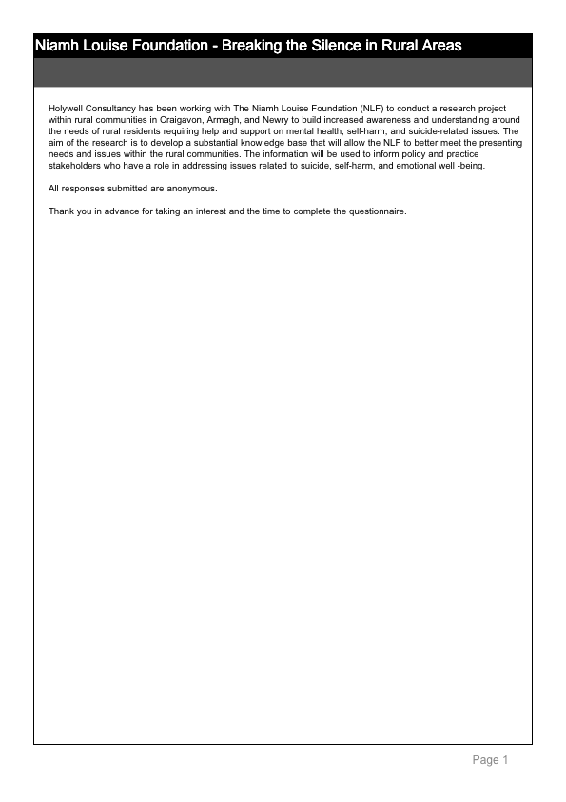

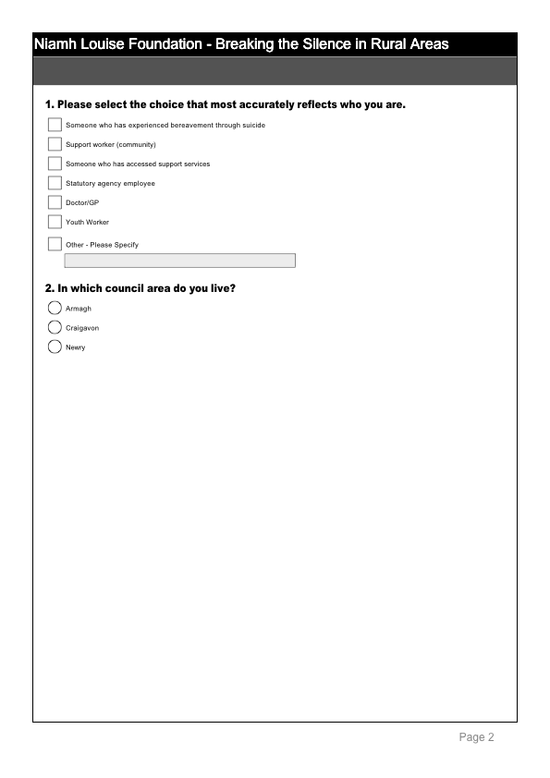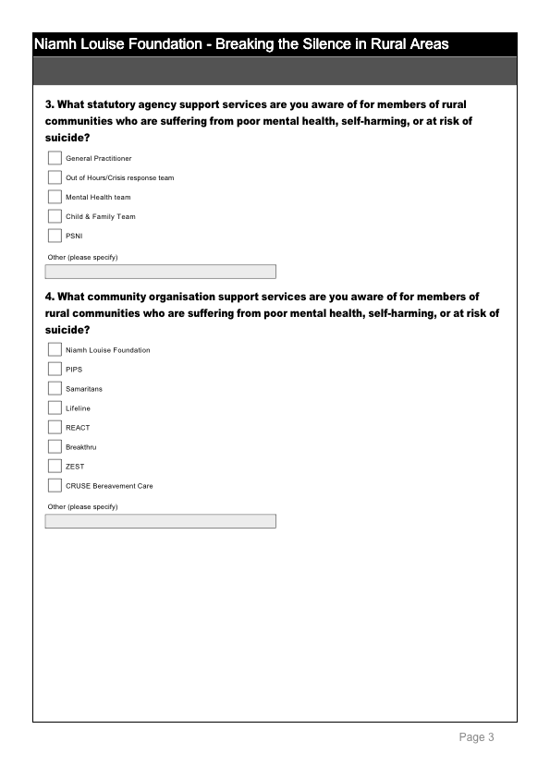

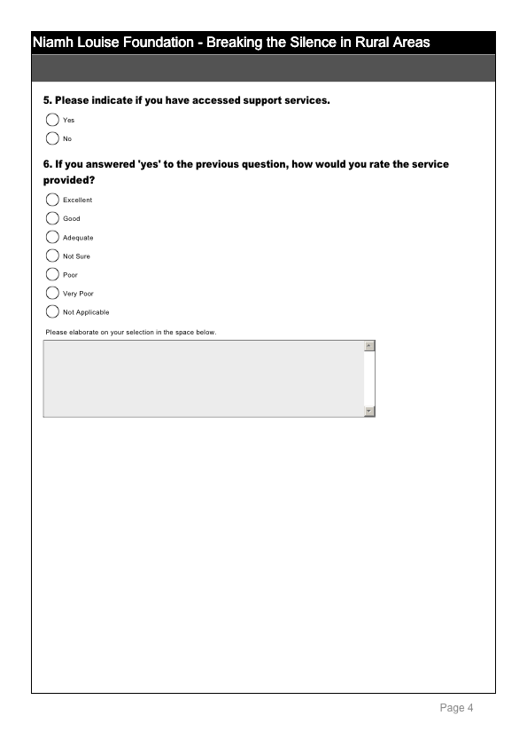
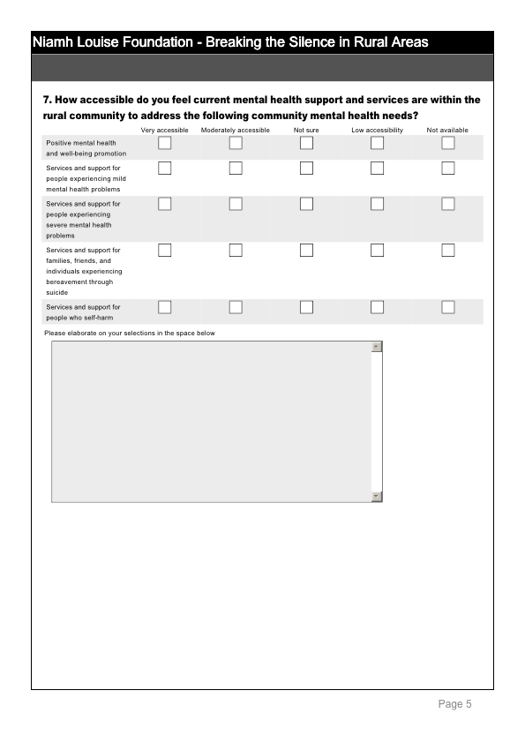
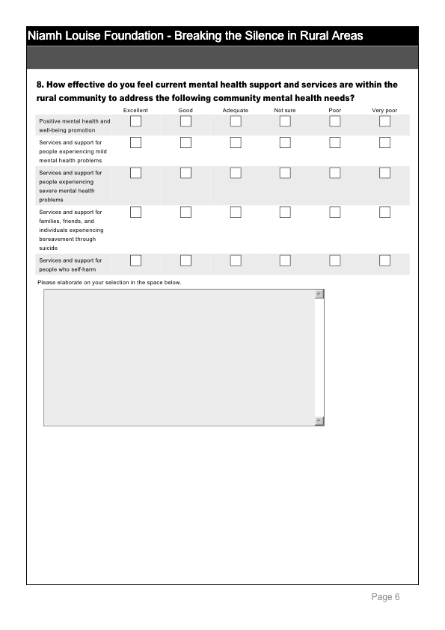
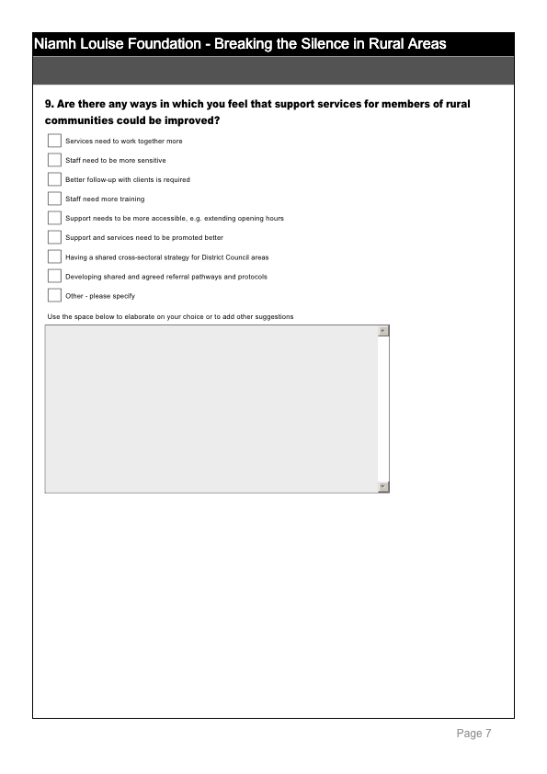
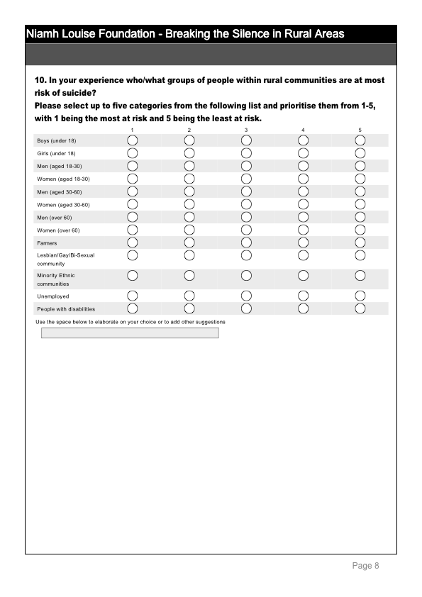
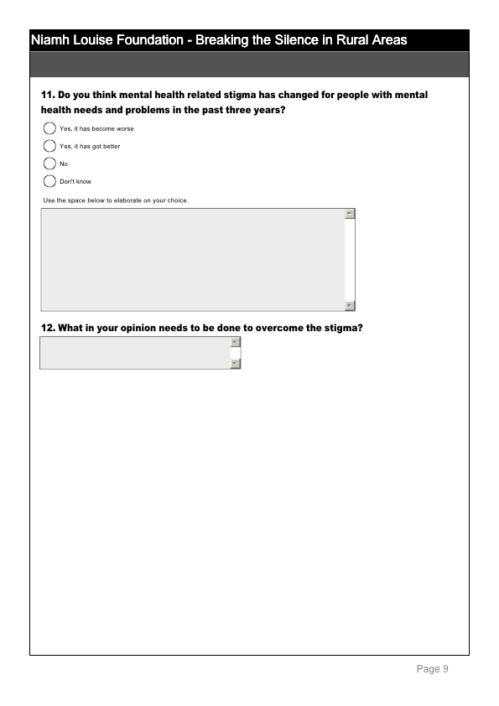
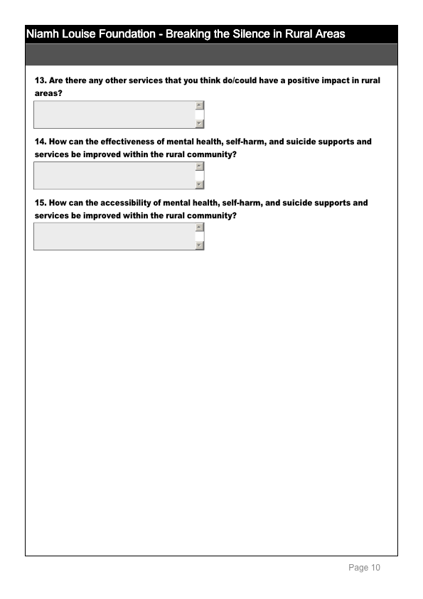
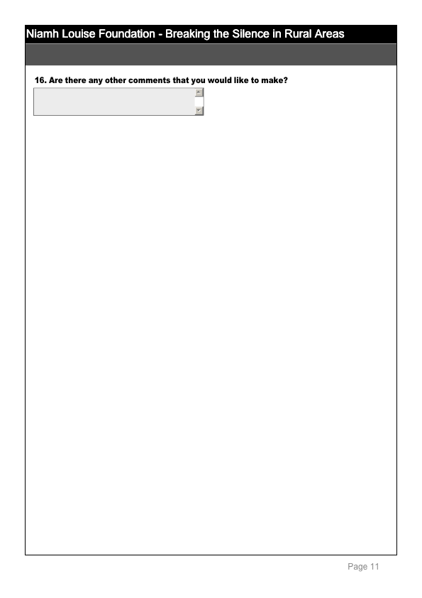
Appendix 6 – Survey Questionnaire – Detailed Findings

39 people responded to the survey questionnaire. 21.1% of the respondents had been bereaved by suicide and 5.3% of the respondents had accessed support services. The remaining respondents ranged from support workers, statutory agency employees, complementary therapists to Doctors/GP’s. The following table illustrates the breakdown of respondents.

Respondents were asked to indicate which council area they lived in. The majority of respondents were from the Craigavon District Council area (48.1%) and 40% were from the Armagh District Council area, with 11.1% from the Newry District Council area. The chart below illustrates the breakdown by council area.

Knowledge/Awareness of services available
Respondents were asked to indicate any statutory services that they were aware of for people within rural communities. 93.9% of respondents indicated that they were aware of the GP as a source of support for members of rural communities suffering from poor mental health, self-harming and at risk of suicide. 72.7% of respondents were aware of the Mental Health team and 63.6% were aware of the Out of Hours/Crisis response team. The chart below illustrates the overall responses.

Respondents were asked to indicate any community support services that they were aware of. With regard to community support services 82.4% indicated being aware of The Niamh Louise Foundation, 85.3% were aware of the Samaritans, 79.4% of Lifeline and 76.5% of PIPS. The table below illustrates the breakdown of responses:

Service provided

Respondents who had indicated that they had accessed support services were asked to rate the service they received:

13.3% felt that it was excellent, 46.7% felt it was good and 20% felt it was adequate. The chart below illustrates the responses:

The following selection of comments from respondents further evidences their experiences:

‘Some aspects are very good, but waiting times for appointments for psychiatric help are not satisfactory’.

‘I have accessed help from support services and found they were fairly good but many people bereaved through suicide need extra support as they are very vulnerable and many don’t know how to get help. Also they need long term support not just six sessions from Lifeline’.

‘The service was good but I had to travel to another area there is nothing in my own community’.

Accessibility

15 out of 29 respondents indicated that they felt there was a low level of accessibility for services and support for people experiencing mild mental health problems, with 7 out of 29 indicating that they felt that services were moderately accessible for those suffering from mild mental health problems. 12 out of 29 respondents indicated that they felt there was a low level of accessibility for services and support for people experiencing severe mental health problems and 10 felt services were moderately accessible.
The chart below illustrates the responses to accessibility of services.

The following selection of comments from respondents further evidences their experiences:

‘I feel there are little services in place for forms of self-harm – those provided directly via GP require the individual to access them and travel to them which is difficult for young people and those in rural areas who don’t drive’.

‘I feel all these services have a low accessibility and that is if you could even manage to get information on them’.

‘I feel that the awareness and understanding of mental health issues is very poor’.

Effectiveness

In response to how effective respondents felt current mental health support is 11 out of 23 respondents felt that the support was poor for people experiencing severe mental health problems and 8 out of 23 respondents felt support was poor for people experiencing bereavement through suicide.

The chart below illustrates the overall responses to this question:

The comments below again provide examples of how effective people feel services and support are:

‘In general I feel current mental health support is very poor’.

‘Those people within the rural communities are more isolated and perhaps are not being reached in terms of promotion of services. Difficulties around transport to these services in order to benefit as well’.

‘There needs to be a greater education through schools/community groups/sports clubs particularly for younger men’.

Improvements
Respondents were asked for ways in which they felt services and support could be improved and were given 9 options to choose from as well as space to elaborate on their answer or to make additional suggestions. 87.5% of respondents felt that services needed to work together more and 75% felt that support and services need to be promoted better. 66% felt that support needs to be more accessible. See chart below for overall responses.

The following selection of comments from respondents further evidences their thoughts:

‘I feel that there should be greater partnership working between voluntary and statutory agencies. Possibly a link person between the services could help voluntary agencies with sign posting to the appropriate service within the statutory service.’

‘I think a lot of work is needed to be done in all these areas. I really feel GPs need to take a bigger role in the community.’

‘Mental health support should not be 9-5 mon-fri. Provision for those unable to travel is needed as is for those in full time education or working. GPs need to be better at signposting people to services that can support when the teams are unable ie when someone is receiving help for self-harm to ensure that they are aware of other options and promote all the services in community at entry point and discharge point’.

Suicide Risk – Rural Communities

Respondents were asked to indicate which groups within rural communities they felt were at risk of suicide. 14 out of 21 respondents indicated that they felt men aged 18-30 were most at risk of suicide. The chart below illustrates the overall responses:

The following is a selection of the respondents comments with regards to who is most at risk of suicide:

‘People with mental illness and previous history of self harm and alcohol and drug misuse. People previously bereaved by suicide.’

‘No particular group is any more at risk, all are at risk’

‘I think anyone can be at risk you can’t just target groups’

Stigma
Respondents were asked if they felt mental health related stigma has changed in the past three years. 45.8% of respondents felt that it had got better and 45.8% felt that mental health related stigma had not changed. The overall responses are illustrated in the chart below:

The following is a selection of comments from respondents with regard to stigma surrounding mental health, self-harm and suicide:

‘I still feel stigma of mental ill health has changed very little in rural areas in NI’.

‘Just as much stigma as ever if not worse.’

‘No I think it is still a very taboo subject’.

There’s more mental health info out there but what we hear from young men is that it isn’t working. They can’t relate to the adverts on TV etc as they don’t see it relevant to their lives’.

Overcoming stigma

Respondents were asked in their opinion what needs to be done to overcome the stigma around mental health. The following is a selection of their responses:

‘I believe there needs to be more education to help people understand poor mental health and that it can affect any one of us.’

Early intervention and prevention work is paramount starting in pre and nursery school addressing emotional health and feelings and how to express these in a healthy way.’

‘More awareness for the public. Take the fear factor out of the condition and allow everyone to see the person and not just the illness.’

‘It needs to be accepted as a disease and for people to be aware that they can get treatment for mental health and it is available to anyone who needs it.’

Improving effectiveness of support
Respondents were asked how they feel the effectiveness of mental health, self-harm and suicide supports and services could be improved within the rural community.

Below is a selection of their responses:

‘Make programmes comprehensive. Maintain existing services and build on those services.’

‘Continuity of care – one care worker assigned to each patient’

‘Ensure all promotion and awareness raising is extended to the rural communities.’

‘More publicity and easier accessibility’

‘As rural communities are small and people all know each other and potentially their business, an agency with workers from outside the area is probably preferable.’

Improve accessibility of support

Respondents were asked how they feel the accessibility of mental health, self-harm and suicide supports and services could be improved within the rural community.

Below is a selection of their responses:

‘More community based centres to support those suffering from mental illness.’

Idea of mobile support units considered. Sometimes people do not want to be seen using supports in their own area but may avail of drop in type provision in other locations’.

‘Perhaps through more protect life resource centres which are open at a variety of times, including evenings and weekends so they are accessible by everyone in the community’.

‘Use existing services. Use venues such as church halls and GAA clubs. Don’t label programmes as being mental health that is a real turn off.

Jordan, J, McKenna H, Keeney, S & Cutcliffe J, 2011, Providing meaningful care: using the experiences of young suicidal men to inform mental health care services

